- Though a US federal court struck down most of the tariffs imposed by President Donald Trump this week, an appeals court has temporarily stayed the ruling. The administration has other tools at its disposal to keep tariffs at elevated levels, so we won't change the tariff assumptions in our June baseline forecast. And trade policy uncertainty is only likely to become more entrenched.
- The Office for National Statistics' latest migration estimates confirmed that immigration fell sharply last year as humanitarian inflows receded and visa requirements were tightened. The drop was slightly larger than expected, and we will nudge down our near-term migration forecasts. This implies slightly weaker growth in labour supply and potential output.
In a week without any major UK economic releases, attention has again focused on developments in US trade policy. On Wednesday evening, the US Court of International Trade struck down the tariffs imposed by President Donald Trump under the International Emergency Economic Powers Act, leaving only the sector-specific tariffs on steel, aluminium, autos, and auto parts in place. This move would have removed the 10% tariff applied to most US goods imports from the UK.
However, a federal appeals court temporarily halted the trade court ruling, keeping the tariffs in effect during the appeals process. Though it's difficult to know whether the administration will eventually win the case, our US team have outlined several alternative legal channels through which the administration can maintain tariffs at elevated levels. So we will refrain from making any changes to our tariff assumptions in our next global forecast update on June 10. As the courts start to play a greater role in determining the level of tariffs, trade policy uncertainty is likely to become even more entrenched.
With few other major developments this week, we turn our attention to the Office for National Statistics' latest migration estimates that were published at the end of last week. The ONS reported that net inward migration fell to 431,000 in the year ending December 2024, from 860,000 a year earlier.
Chart 1: Tougher visa requirements have weighed on work, study, and dependents-related inflows
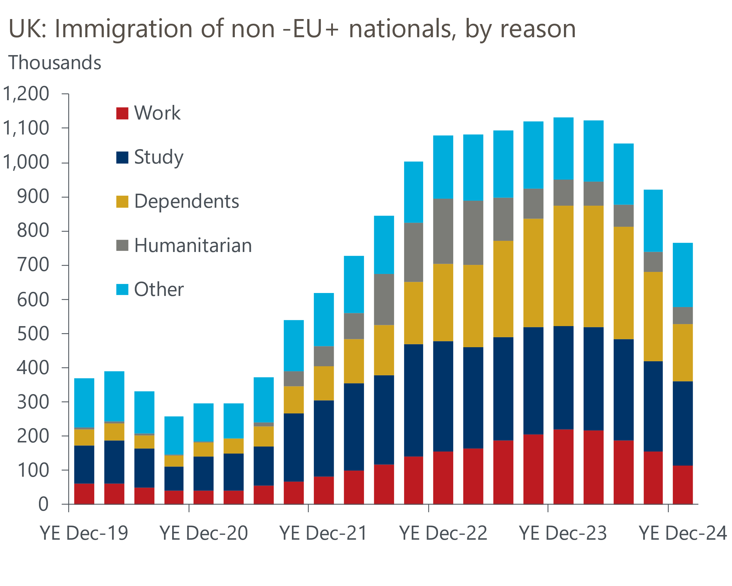
Source: ONS

The breakdown showed that the rapid decline in net inward migration from the very high levels seen in 2022 and 2023 was primarily driven by a decrease in immigration of non-EU+ nationals. There are two main strands to this story.
First, there has been a significant reduction in the number of people immigrating to the UK on work and study-related visas, as well as their dependents (Chart 1). This follows measures implemented by the previous government in 2024 that raised the minimum salary for a skilled work visa, increased the minimum income required to qualify for a spousal visa, and limited the ability of foreign students to bring dependents to the UK.
Second, exceptionally high inflows in recent years partly reflected special humanitarian visa schemes for migrants from Hong Kong and Ukraine, as well as the Afghan resettlement programme. But the temporary nature of these schemes meant inflows from these sources were always likely to fall back in subsequent years.
There was high uncertainty around the pace at which the recent rise in net inward migration would unwind, both in terms of whether recent high levels of immigration would subsequently trigger higher levels of emigration and around how effective government measures would be at cutting legal immigration. When the ONS published its most recent population projections in January, it published an additional scenario that made different assumptions around those factors, resulting in a lower level of net immigration. Last week's data suggests net inflows are tracking much closer to that lower 'migration category variant projection' than the ONS's principal projection.
Our forecasts built in a bigger drop in net migration than the ONS's principal projection. But with the scale of the decline slightly larger than we had expected, we will nudge down our near-term migration projection when we publish our next UK forecast as part of our global update on June 10.
A lower net migration assumption implies a weaker outlook for the working age population and labour supply. The UK's growth performance has been poor since the Global Financial Crisis, even with strong support from an expanding workforce. But that support is now waning, not just through lower net immigration but also from ageing and smaller increases in the state pension age. This will put an even bigger onus on improvements in productivity to drive potential output growth.
We see some scope for higher productivity growth to mitigate the hit to potential output from weaker labour supply. This partly reflects a belief that we are unlikely to see a repeat of the succession of negative shocks (global financial crisis, Brexit, the pandemic, Russia's invasion of Ukraine, and the recent increase in US tariffs) that have weighed so heavily on productivity growth over the last 15 years. We are also cautiously optimistic that planning reform and developments in AI and climate technologies will offer some support. But with the boost from expanding labour supply waning, we continue to think that over the medium term, potential output growth is likely to remain much lower than in the decades prior to the GFC.

The week ahead
In recent months, mortgage demand has fallen modestly as the temporary boost to activity from households looking to beat March's stamp duty cut-off unwound. Experience of similar stamp duty changes in the past suggests this process likely has further to run. Therefore, we forecast that mortgage approvals declined to 62,600 in April, from 64,300 in March.
Net secured lending soared in March, as borrowers completing purchases ahead of the stamp duty deadline caused gross lending to rise substantially. But there will have been payback in the following month, so we anticipate that net secured lending fell £1.2bn in April.
On the unsecured side, higher repayments more than offset a slight increase in gross lending in March. Though we think gross lending may have fallen fractionally in April, we expect repayments to have declined by a slightly larger margin. As a result, we estimate that net consumer credit was £1bn in April, up from £0.9bn in March.
Following a very sharp fall in April, May's flash S&P Global survey reported a much less severe contraction in private sector activity growth. The less downbeat reading was entirely driven by a modest improvement in services activity, while manufacturing output declined at a faster pace. Though we expect next week's final survey to reiterate this picture, the sensitivity of the survey's recent results to US trade news suggests significant trade developments at the end of this month may result in greater revisions than usual.
Table 1: Week ahead calendar
Date | Events | Period | Measure | Unit | Previous | Forecast
Jun 2 | Mortgage approvals | Apr | Level | 000s | 64.3 | 62.6
Jun 2 | Mortgage lending | Apr | Net lending | £bn | 13.0 | -1.2
Jun 2 | Consumer credit | Apr | Net lending | £bn | 0.9 | 1.0
Jun 2 | S&P Global manufacturing | May | PMI | % bal | 45.1 | 45.1
Jun 2 | Nationwide house prices | May | m/m | % | -0.6 | 0.1
Jun 2 | Nationwide house prices | May | y/y | % | 3.4 | 2.9
Jun 4 | S&P Global services | May | PMI | % bal | 50.2 | 50.2
Jun 4 | S&P Global composite | May | PMI | % bal | 49.4 | 49.4
Jun 5 | S&P Global construction | May | PMI | % bal | 46.6 | 47.2
Jun 6 | Halifax house prices | May | m/m | % | 0.3 | -0.1
Jun 6 | Halifax house prices | May | y/y | % | 3.2 | 3.0
Source: Oxford Economics

Key forecasts
Table 2: UK forecast overview
(Annual percentage changes unless specified)
 | 2022 | 2023 | 2024 | 2025 | 2026 | 2027
GDP | 4.8 | 0.4 | 1.1 | 1.2 | 0.9 | 1.3
Private consumption | 7.3 | 0.5 | 0.6 | 1.0 | 1.2 | 1.3
Fixed investment | 5.1 | 0.3 | 1.5 | 2.0 | 0.6 | 1.6
Government consumption | 0.6 | 1.6 | 3.0 | 1.5 | 1.7 | 1.6
Exports of goods and services | 12.6 | -0.4 | -1.2 | 0.9 | -1.3 | 1.2
Imports of goods and services | 13.0 | -1.2 | 2.7 | 1.5 | -1.0 | 1.1
Industrial Production | -6.4 | -0.8 | -1.2 | 0.0 | -0.3 | 0.7
Consumer prices | 9.1 | 7.3 | 2.5 | 3.0 | 2.4 | 2.3
Unemployment rate (%) | 3.8 | 4.1 | 4.3 | 4.6 | 4.9 | 4.8
Current a/c balance (% of GDP) | -2.2 | -3.5 | -2.7 | -2.7 | -2.7 | -2.6
Government balance (% of GDP) | 4.3 | 5.2 | 5.1 | 4.4 | 3.6 | 2.9
Central bank policy rate (%, EOP) | 3.50 | 5.25 | 4.75 | 3.75 | 3.00 | 2.50
10yr govt. bond yield (%, EOP) | 3.67 | 3.54 | 4.57 | 4.48 | 3.95 | 3.45
Exchange rate (US$ per £, EOP) | 1.20 | 1.27 | 1.25 | 1.32 | 1.32 | 1.32
Exchange rate (euro per £, EOP) | 1.13 | 1.15 | 1.21 | 1.17 | 1.17 | 1.17
Source: Oxford Economics
Table 3: Quarterly forecasts for the UK
 | 2025 |  |  |  | 2026
 | Q1 | Q2 | Q3 | Q4 | Q1 | Q2 | Q3 | Q4
GDP (% year) | 1.3 | 1.0 | 1.1 | 1.2 | 0.7 | 0.8 | 0.9 | 1.0
CPI inflation (% year) | 2.8 | 3.1 | 3.3 | 2.9 | 2.7 | 2.1 | 2.3 | 2.4
Bank Rate (%, EOP) | 4.50 | 4.25 | 4.00 | 3.75 | 3.50 | 3.25 | 3.25 | 3.00
10yr gilt yield (%, EOP) | 4.70 | 4.70 | 4.59 | 4.48 | 4.36 | 4.23 | 4.10 | 3.95
US$ per £ (EOP) | 1.29 | 1.32 | 1.32 | 1.32 | 1.32 | 1.32 | 1.32 | 1.32
Euro per £ (EOP) | 1.20 | 1.17 | 1.17 | 1.17 | 1.17 | 1.17 | 1.17 | 1.17
Source: Oxford Economics

Latest Country Economic Forecast:
May 20, 2025

Recent publications

Data Insights
Retail sales surged again in April
PMI rebounds in May, but likely remains too downbeat
Public finances remain in a precarious state
Upside surprise for inflation unlikely to alter BoE's cutting cycle
Strong GDP growth in Q1 likely flatters the underlying conditions

Research Briefings
What the EU deal means for trade and growth
Employment nowcast suggests limited impact from NICs rise
MPC stays on its "gradual and careful" path
MPC Preview – tariffs could prompt a less cautious approach
How will central banks react to the trade war?

Contacts

Oxford Economics' UK team
- Andrew Goodwin - Chief UK Economist - agoodwin@oxfordeconomics.com
- Edward Allenby - UK Economist - eallenby@oxfordeconomics.com

